MySQL Assignment 1 – DDL Commands & Constraints
Fathima minha.p
DDL Commands :
- Table Creation (CREATE): Write the SQL statements to create a database named “employee” and the following tables based on the provided schema:
⦿ Departments
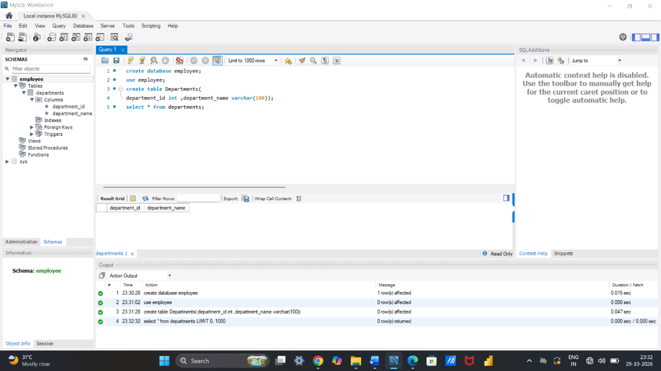
⦿ Location
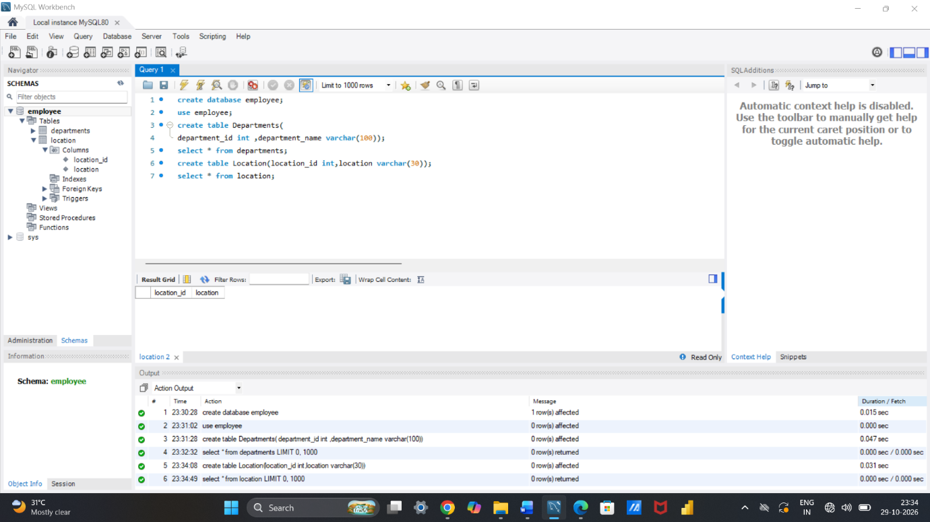
⦿ Employees
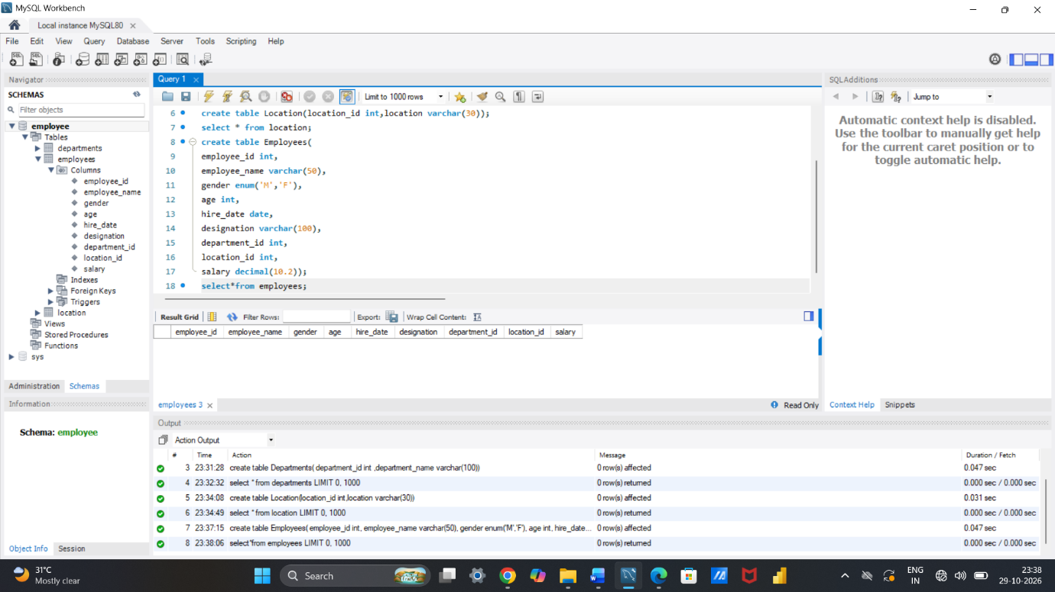

- Table Alteration (ALTER):
Consider the following scenarios and write the SQL statements to alter the structure of the tables accordingly:

⦿ Add a new column named "email" to the Employees table to store employee email addresses.
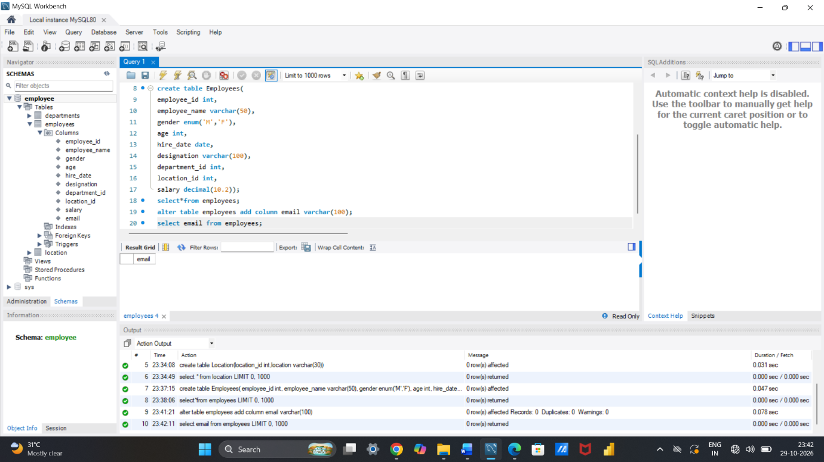
⦿ Modify the data type of the "designation" column in the Employees table to support a wider range of values.
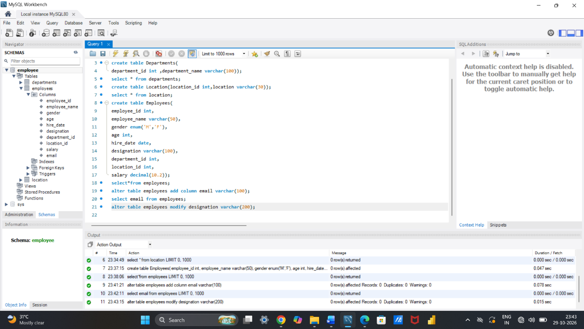
⦿ Drop the “age” column from the Employees table.
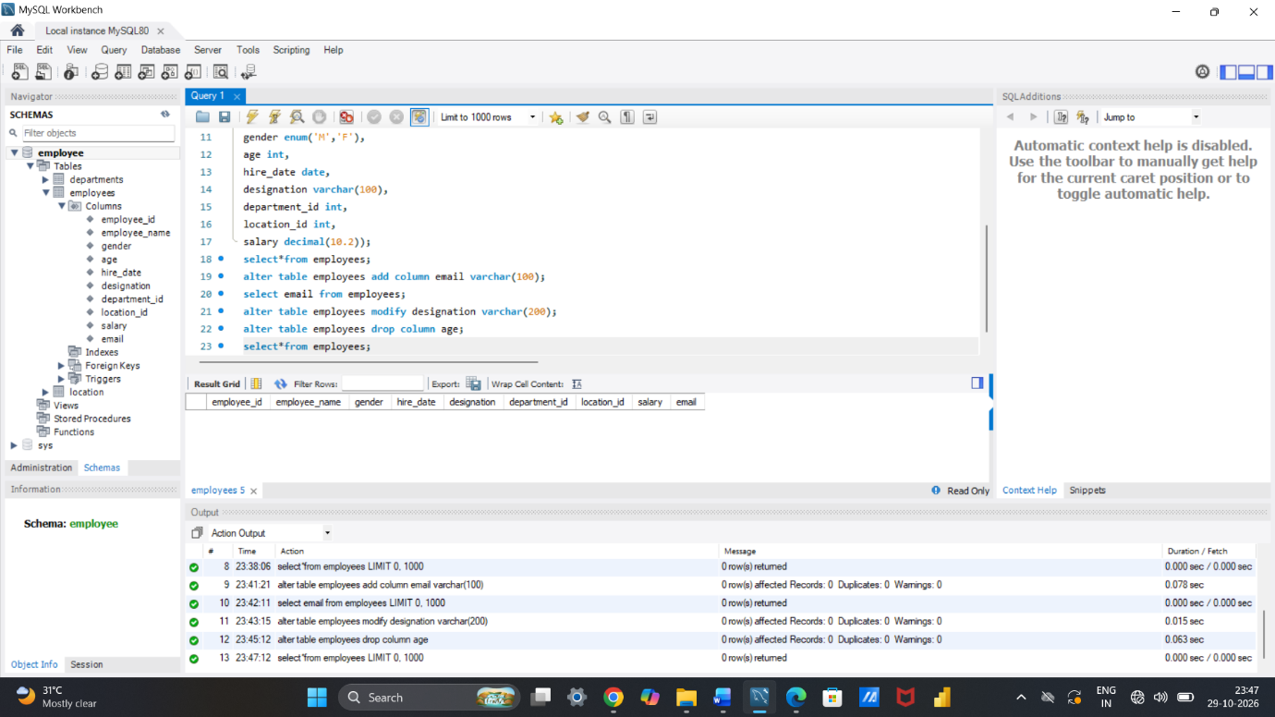
⦿ Rename the “hire_date” column to “date_of_joining”.
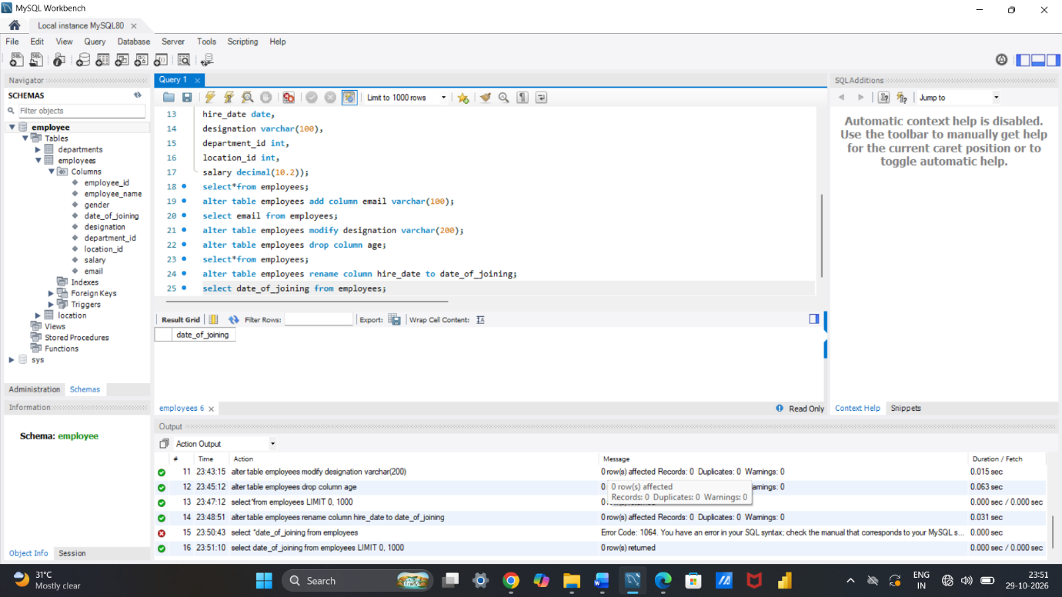

- Table Renaming (RENAME):
Rewrite the SQL statements to rename the following tables: ⦿ Rename the "Departments" table to "Departments_Info". ⦿ Rename the "Location" table to "Locations".
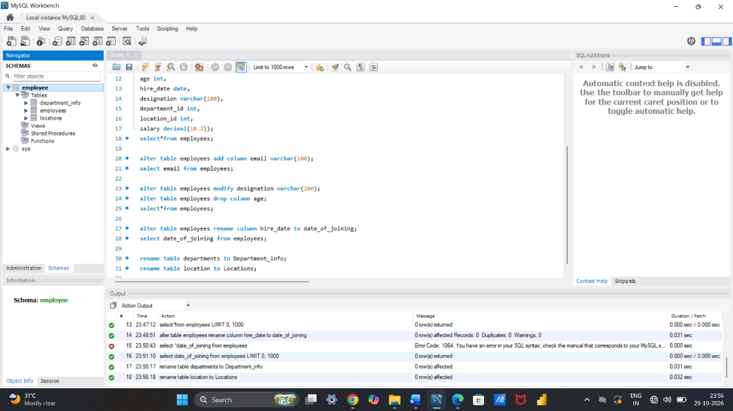

- Table Truncation (TRUNCATE):
Write an SQL statement to truncate the Employees table.
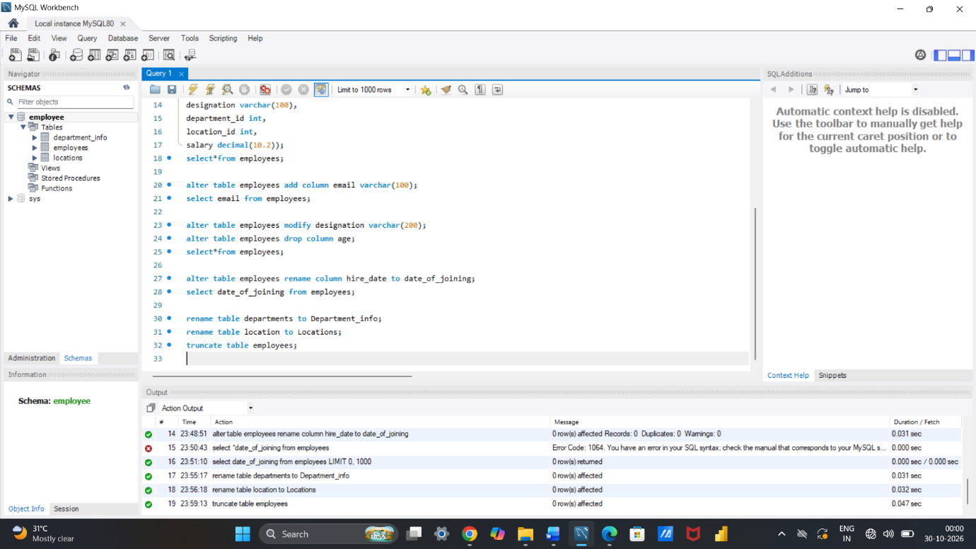
- Database & Table Dropping (DROP):
Write the SQL statements to drop the
Employees table
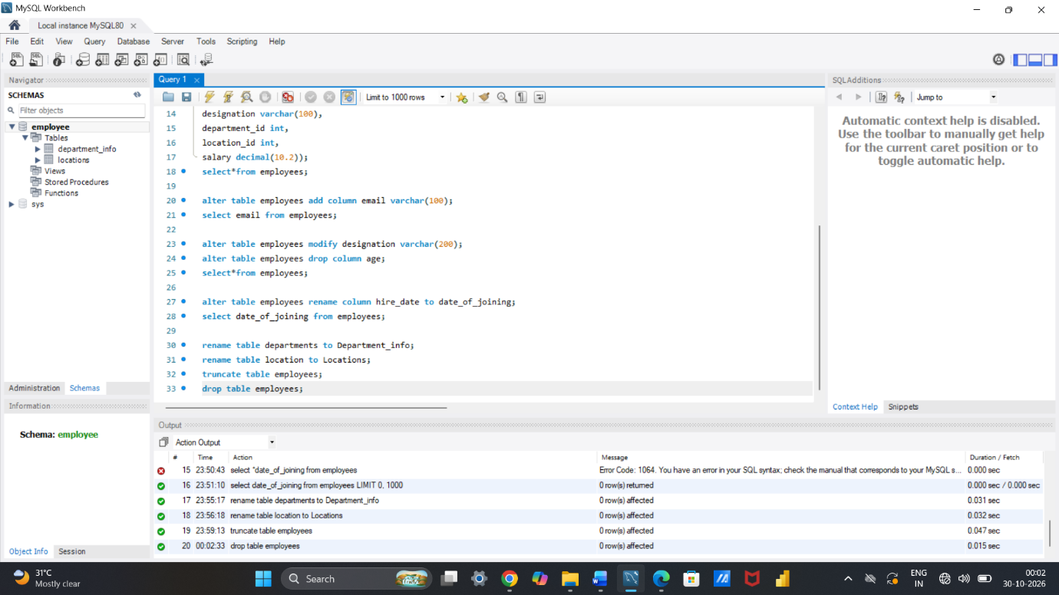
and then the “employee” database.
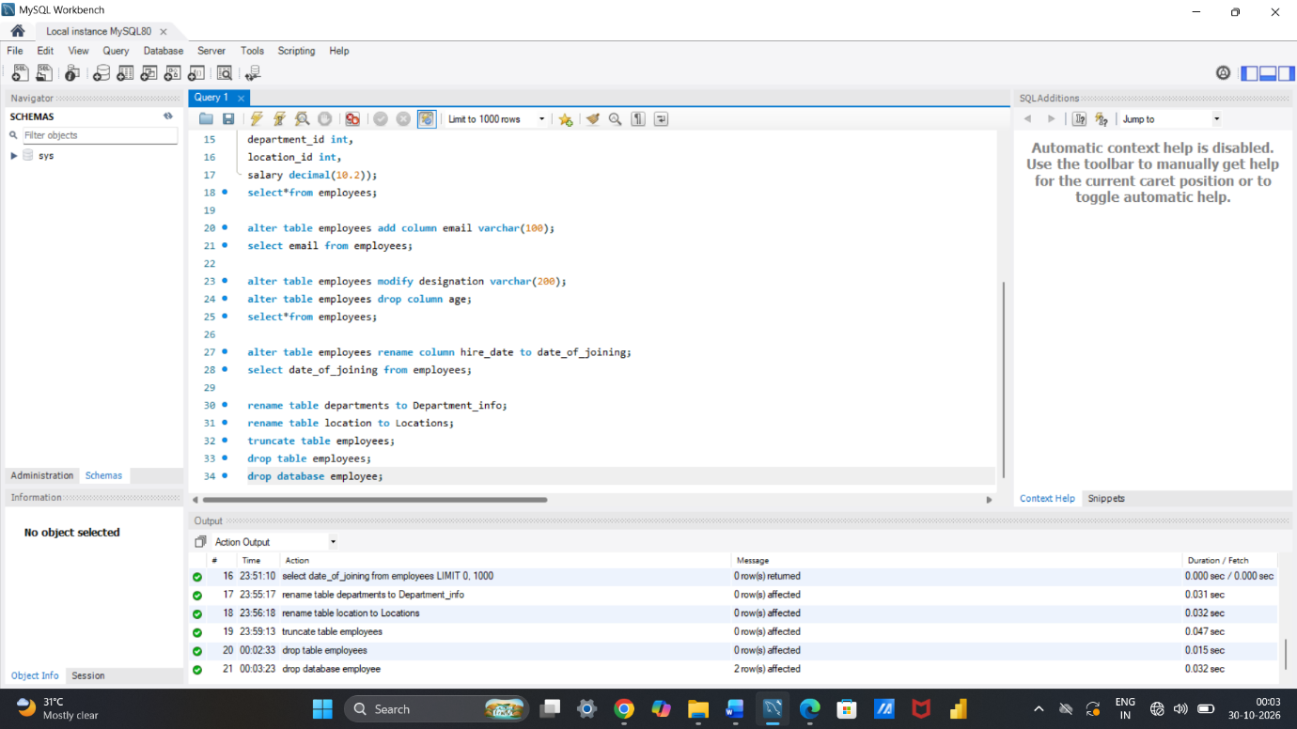
Constraints :
1. Database Recreation:
⦿ Drop the 'employee' database if it exists and recreate it using the
provided schema, ensuring that all tables are created with the
appropriate constraints as instructed.
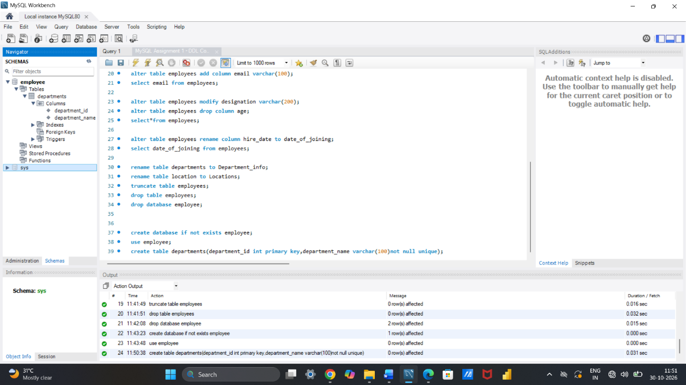
2. Departments Table:
⦿ Ensure that the "department_id" uniquely identifies each department.
⦿ Set up constraints on the "department_name" to avoid duplicate and null
entries.
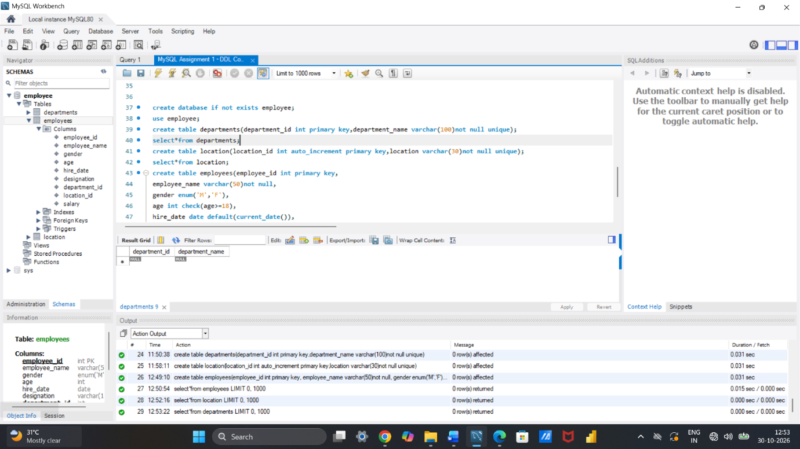

3. Location Table:
⦿ Establish a mechanism to automatically generate unique identifiers for each location, ensuring that they are incremented sequentially.
⦿ Implement constraints to prevent the insertion of null and duplicate locations.
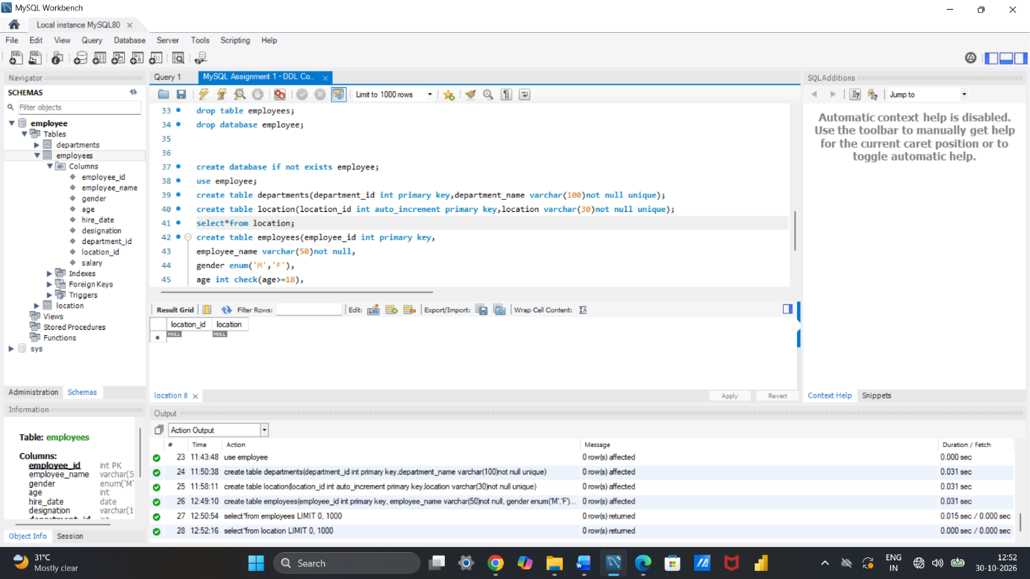
4. Employees Table:
⦿ Guarantee that each employee has a distinct identifier.
⦿ Create a restriction to ensure that the employee's name is always provided.
⦿ Limit the acceptable values for the "gender" field to only 'M' or 'F'.
⦿ Enforce a condition to ensure that the employee's age is 18 or above.
⦿ Automatically assign the current date to the "hire_date" field if not specified.
⦿ Establish links between the "department_id" and "location_id" fields in the "employees" table and their respective tables.


